

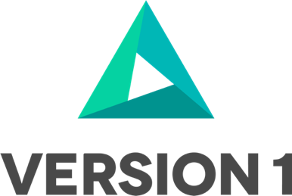

Hiring Dashboard

By Neeta Surkante

Version: 1.0

©Copyright 2022 Version 1 – All Rights Reserved

1. You can delete any elements of this cover page that you do not need for your document. For example, Copy Number is only required if this is a controlled document and you need to track each copy that you distribute.

Document Control

2

|  |  |  |  |
| --- | --- | --- | --- |
| Date | Author | Version | Change Reference |
| 19-Apr-2023 | Neeta Surkante | 1.0 | No Previous Document |
|  |  |  |  |
|  |  |  |  |
|  |  |  |  |

Reviewers

|  |  |  |  |
| --- | --- | --- | --- |
| Name | | Position | |
| Ved Prakash Chauhan | Solutions Architect | |  |
|  |  | |  |
|  |  | |  |
|  |  | |  |
|  |  | |  |
|  |  | |  |

Distribution

|  |  |  |
| --- | --- | --- |
| Copy No. | Name | Location |
|  |  |  |
|  |  |  |
|  |  |  |
|  |  |  |

1. The copy numbers referenced above should be written into the **Copy Number** space on the cover of each distributed copy. If the document is not controlled, you can delete this table, the Note To Holders, and the **Copy Number** label from the cover page.

Contents

Document Control i

Reviewers i

Distribution i

1 Overview 3

2 Major Features 4

3 ASSUMPTIONS 5

4 Pre-requistes 6

5 Report 7

5.1 New Reports 7

5.2 New Drill down Reports 7

5.3 Report Logic 8

6 Data Mapping 10

7 Test scenarios 11

8 Open and Closed Issues for this Deliverable 12

8.1 Open Issues 12

8.2 Closed Issues 12

# Overview

This document will give an overview Aspire ORC dashboard. Purpose of the dashboard is to showcase the current state of Recruitment process of the organization.

This will also include the pain points the hiring team is facing so those can be addressed. We are using multiple reports and filters to give the accurate data to management.

The graphical representation is also included which will be presenting the reports data in more visual way.

# Major Features

The salient features of the dashboard will be as follows.

1. Overview of Organization whole recruitment process
2. Dashboard will give states of all recruiting transactions.
3. Pain points of the hiring team will be easily identifiable.
4. Filters provided on the dashboard and reports will help the user compare data within different teams/departments.

# ASSUMPTIONS

* Whole recruiting cycle is done in ORC
* Offer extensions done only in the system

# Pre-requistes

Recruiting data related to Requisition ,candidates and Offer is well stored in the system.

# Report

The report formats will include the following:

* The reports generated will be in EXCEL format.

## New Reports

There will new Level 2 report showcasing the summary of metrics shown on the level1.

* Avg Time to hire
* Turn Over Rate
* Recruiting Closure Rate

## New Drill down Reports

1. Requisition approval & Posting Report

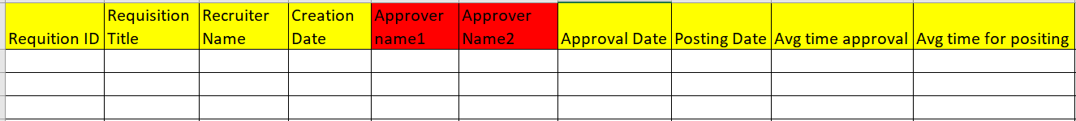

1. **Candidate Selection Report**

|  |  |  |  |  |  |  |  |
| --- | --- | --- | --- | --- | --- | --- | --- |
| Req Id | Req Name | Candidate Name | Applied on | Selection Date | Offered Creation | Extended Date | Avg Offer Time |
|  |  |  |  |  |  |  |  |
|  |  |  |  |  |  |  |  |
|  |  |  |  |  |  |  |  |
|  |  |  |  |  |  |  |  |

1. Hard Closure Report

1. Offer Report

1. Recruiter Performance Report

## Report Logic

1. **Avg Time to hire**

This will be showing the average time of each recruiting transaction from Requisition creation to Move to HR of candidate.

**Filter**: By default the results will be shown for all organization further filter will be available to see the data by Job category, Location, LE, Time range

* 1. **Requisition Approval & posting Report**

This report will include the actual data showing the time taken by each transaction against the requisition. This will help business to investigate the area where most of the time being taken which is resulting in delay of requisition posting.

**Filter :** Job Category, Department, Location, Date Range. By default all will be selected as filter.

* 1. **Candidate Selection Report**

Candidate movement through the selection process, time taken by interviewers , final selection will be included in this report.

**Filter**: Interviewer Name, Interview Level, Mode of interview, Recruiter

* 1. **Hard Closures**

There could be few niche skills/job requirement which gives tough time to hiring team. Those will be included in this report.

**Filter: Candidate Source, Job Category, Job Level**

1. **Turn Over Rate**

Here a brief of the offer ratio will be shown. How many offers were released and what’s is the acceptance ratio can be seen here.

* 1. **Offer Report**

In this report offers created, extended, accepted, and rejected around the organization will be included. The report will be mainly focusing on the offer drop out to minimize the numbers in coming time.

**Filter:** Offer Status, Rejection reason,Location, Category, Age Group

1. Recruiting Closure Rate

This is the area where hiring team’s performance can be seen via the closure of their requisitions.

* 1. **Recruiting Performance Report**

Showing the details of individual Recruiter’s performance is the purpose of this report. Requisition raised, offer made, Requisition closed , avg time taken by the recruiter will be included here, offer acceptance rate.

**Filter:** Time Range, Job category, Recruiter name

# Data Mapping

For Data mapping below fields from the hiring workspace will used.

|  |  |  |
| --- | --- | --- |
| Reporting Fields |  |  |
| Requisition Name |  |  |
| Requisition ID |  |  |
| Recruiter Name |  |  |
| Candidate Name |  |  |
| Candidate email ID |  |  |
| Requisition Creation Date |  |  |
| Requisition Approved Date |  |  |
| Requisition Filled Date |  |  |
| Candidate Applied date |  |  |
| Offer creation Date |  |  |
| Offer approval date |  |  |
| Offer extended date |  |  |
| Candidate current status |  |  |
| Rejection reason |  |  |
| Move to HR date |  |  |
| Interview dates |  |  |
| Interviewer Name |  |  |
| Approver name |  |  |
| Requisition Location |  |  |
| Candidate Location |  |  |
| Candidate Age group (if being captured |  |  |

# Test scenarios

| # | Scenario | Description |
| --- | --- | --- |
|  |  |  |
|  |  |  |
|  |  |  |
|  |  |  |
|  |  |  |
|  |  |  |
|  |  |  |
|  |  |  |
|  |  |  |
|  |  |  |

# Open and Closed Issues for this Deliverable

## Open Issues

|  |  |  |  |  |  |
| --- | --- | --- | --- | --- | --- |
| ID | Issue | Resolution | Responsibility | Target Date | Impact Date |
|  |  |  |  |  |  |
|  |  |  |  |  |  |
|  |  |  |  |  |  |
|  |  |  |  |  |  |
|  |  |  |  |  |  |

## Closed Issues

|  |  |  |  |  |  |
| --- | --- | --- | --- | --- | --- |
| ID | Issue | Resolution | Responsibility | Target Date | Close Date |
|  |  |  |  |  |  |
|  |  |  |  |  |  |
|  |  |  |  |  |  |
|  |  |  |  |  |  |
|  |  |  |  |  |  |



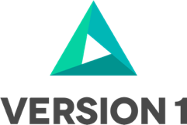

[www.version1.com](http://www.version1.com)